Specification of FreePIPE Pipe Nesting and Cutting Software
Nantong AiTe Software Co.,Ltd.
www.it-soft.cn

CONTENTS
CONTENTS 2
Description of Software Functions and Features 4
Disclaimer 6
Operating Environment of the Software 7
Software Installation 8
Concept and Terms 9
Theoretical Origin 9
Angle 0 Position 9
Dynamic bevels of 8 Points 9
Full Dynamic bevel 9
Fixed bevel 10
Broad End-grain Cutting Style 10
The Main Form of the Software 11
The Form of personnel Editing 12
The Form of Materials Editing 13
The Form of Software Setting 14
The Form of Pipe Parts Editing 16
The Form of Node Selecting 17
End-grain Cutting 18
Slotting at the End 20
Tapping 22
Tapping of Intersecting Line When the Main Pipe Generates Branch Pipes 24
End-grain Cutting of Intersecting Line Where the Branch Pipes and Main Pipe Connect 26
Intersection of Three Pipes 27
Combined Intersection of Branch Pipe, Main Pipe and Another Branch Pipe 28
Modifying Nodes 30
Deleting Nodes 30
Highlighting of Node Graph 31
Generating G Code 31
Pipe reverse 32
Save 33
The Form of Automatic Nesting 35
Pipe Material 36
Pipe Parts 37
Nesting Result 38
Revealing of Pipe Part Matching the Pipe Material 40
Saving the Information of Nesting 41
Saving the Nesting Result of Single Pipe 41
Generating G Code 43
Reading In the Pipe 44
Modifying the Parameters of Lead-in and Lead-out Lines 47
Savign G Code 47
Cutting Simulation 50
G Code Call-in and Cutting Simulation 51
Extended Tools 53
Generator of Split Elbow 53
The Operation in the Drawing Area 55
Introduction to the Distribution of Trail Encryption Lock with Time Limit 57
Contact Us 58
About Us 58
Address and Contact 58

Description of Software Functions and Features

FreePIPE is a general software of calculating intersecting lines, nesting and cutting of pipe, which is powerful and easy-to-use, etc. It is applicable for those companies that are engaged in manufacturing pipe truss or fluid pipe. After the user inputs some basic parameters, the software will automatically calculate the cutting line according to what the user inputs. The unique function of automatic nesting of pipe parts will make you cut the whole piece of steel pipe material into several pieces of steel pipe at one time, during which no manual operation is needed. It is as easy to cut steel pipe as it is to cut steel plate. Besides, the automatic nesting of pipe by computer fulfils the optimization of pipe material usage, which helps to save material cost, greatly reduce cutting time and improve the efficiency of cutting machine.
The software now can be used to generate and cut the following types of pipe cutting node:
- Vertical or aslant cutting of the pipe.
- Slotting at the end of the pipe. According to the parameters you have set, it can be slotted at the end of the pipe in the width and length as you required.
- Holes in various shapes on the pipe. As long as you can draw the holes in the shape you want with CAD(For the time being, only those of straight line, arc and circle are supported), the software will project the shape you have drawn to the pipe wall, and hole in the same shape.
- Various holes of intersecting lines used to generate branch pipes on the main pipe. The software can generate automatically the holes of intersecting lines used to generate branch pipes on the main pipe according to the relative position of branch pipes and main pipe.
- The generation of intersecting lines at the ends of branch pipes where the branch pipes intersect with the main pipe. The location and shape of intersecting lines at the ends of branch pipes can be generated automatically according to the relative position of branch pipes and main pipe.
- The shape at the end where the three pipes intersect. The shape at the end where the three pipes intersect can be generated according to the basic parameters input.
- The combined intersecting lines between branch pipes and main pipe or between branch pipes and other branch pipes when there are two or more branch pipes on the main pipe. The combined intersecting lines can be generated automatically according to the simple and visualized parameters the user inputs, which simplify complicated problems. It conforms to the common sense to set and adjust various intersections of three pipes on the same interface through several parameters, and the users need no profound knowledge of three-dimensional angle calculating, which is easy and swift to operate. The perfect function of bevel definition can define most of the bevels, and bring the given bevel into G code when the code is being generated. There are three kinds of code that can be defined by the users: dynamic bevels of 8 points, full dynamic bevels and fixed bevels, which can meet the requirements of the majority of customers.

The graphics files generated by the software can be saved as DWG or DXF format to be edited and verified by CAD (The converting software of FormatConverter included in the software needs to be installed.)

The users of the software can customize the standards of outer diameter and wall thickness of the pipe by themselves. There is the list of ASTM standard pipe diameter and wall thickness in this software. The users can edit the standards of outer diameter and wall thickness of the pipe that comply their requirements, which eliminates the trouble of checking the standards and inputting repeatedly.

The function of automatically pipe nesting. This function saves your precious time and material, as well as cutting consumables.

The function of dynamically simulating cutting in full three-dimension. This function can demonstrate the motion state and angle of the cutting device and pipe in real time when the NC cutting is conducted. The interface is so visualized that it is easy to predict the possible problem during cutting.

G code returns into graph and simulates cutting. This function can enable the G code which was generated before to return into three-dimensional graph and simulate cutting in order to facilitate checking the correctness of G code.

The output type of G code can be defined. Defining through the setting files in the software is very flexible and convenient. The users can delete the needless setting files, so that they do not need to choose among a number of output code types, which makes the program interface clearer and easier to operate.

Strong expandability of the software. This software is a product of exclusive intellectual property rights. Our company owns all the core technology and source code of this software, and we can also customize and develop according to the requirements of users if they have special requests.

Disclaimer
The software provides a programming environment of simple and convenient pipe cutting. But since the pipe cutting is complicated system engineering, this software cannot guarantee that correct G code can be generated in any cases.

Before using G code for actual cutting, the users should conduct relevant verification like simulating cutting, and take the responsibility of checking and verifying whether the G code generated is correct. Hereby we declare that we are not responsible for any problem and consequence produced which are caused by the improper operation of the users or their failure to fulfill the responsibility of checking and verifying.

Operating Environment of the Software
The following environments are needed to operate the software:
Hardware requirement: CPU: above 1.0GHz, internal storage: above 1GB, hard disk: the spare space is above 1GB.
Operating system: WINDOW XP、VISTA、WIN7 or versions above those.
FRAMEWORK: dotnetframework3.5 or versions above it.
If the graph generated by this software needs to be saved as the file in DWG format, the support from “Formatconverter_Lite” included in the software is needed.
The above assistant software or tools have been included in the installation disc. Please install by yourself if needed, or run the file of “Setup All.bat” in the disc to install all of them.

Software Installation
If the users want to install all the software and accessories, please run the “Setup All.bat” in the disc, thus the main program, format converting program and FRAMEWORK3.5 (The program will automatically judge whether it needs to be installed according to the operating system) in the software will all be installed into your computer.

If only the main program is needed, please run the program of “Setup.exe” in the disc, and perform the installation of the main program.

If the format converting software needs to be installed separately, which enables the graphics files generated by the software to be saved as DWG format to be checked and verified by the software of CAD, it can be installed by running “disc\Formatconverter_Lite\setup.exe”.

If FrameWork3.5 needs to be installed separately, it can be installed by running “disc\dotNetFramework\dotNetFx35setup.exe”.

All of the above programs and procedural documents are in the installation disc.

Concept and Terms
Here, we introduce the professional terms and their concepts used in the software, and some special terms of the software. To enable you to master the software easily, please firstly look through this chapter before read the following chapter.

Theoretical Origin
Theoretical origin is a virtual point we defined, which plays a role like the origin of coordinates in CAD or other drawing software. The origin is not a real point, which just acts as an absolute origin in theory.

Angle 0 Position
The definition of rotation angle is: looking over the theoretical origin of the pipe, the position on the straight right is 0 degree in theory; with the anticlockwise direction being the positive direction; the position on the straight left is 180 degree; and the position vertically below is 270 degree, as shown in Figure Eleven.
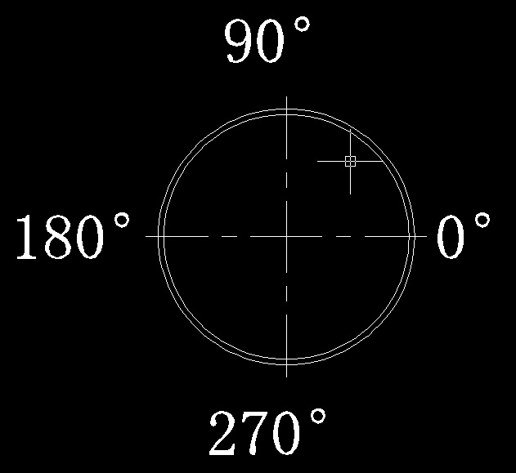
Figure Eleven

Dynamic bevels of 8 Points
Dynamic bevels of 8 points refer to the angles of 8 points whose angle differences with the 0 position are respectively 0, 45, 90, 135, 180, 225, 270 and 315 degrees. The angles of other points can be calculated through the 8 points in a linear way of calculation.

Full Dynamic bevel
Full dynamic bevel is that the final bevel angle is determined according to the bevel angle which is actually calculated by the software, added with the bevel angle that the user inputs.

Fixed bevel
The definition of fixed bevel of this software is different from that of common software. The fixed bevel of this software refers to: on the basis of the intersecting line of the calculated theoretical cutting line and inner surface of pipe, the present calculated cutting line should be applied if the calculated line of the outside exceeds the original one; otherwise the offset should be conducted according to the calculated cutting line of the outside. Thus it will guarantee that more pipes will be cut out to meet the requirements of assembly.

Broad End-grain Cutting Style
End-grain cutting can be divided into broad one and narrow one. Broad end-grain cutting refers to all the cutting types, including end-grain cutting, intersecting line end-grain cutting of branch pipes, end-grain cutting of three-pipe intersection and end-grain cutting of multi-pipe intersection.

The Main Form of the Software
The software applies the design of multi-document interface, and the main form of it is as following:

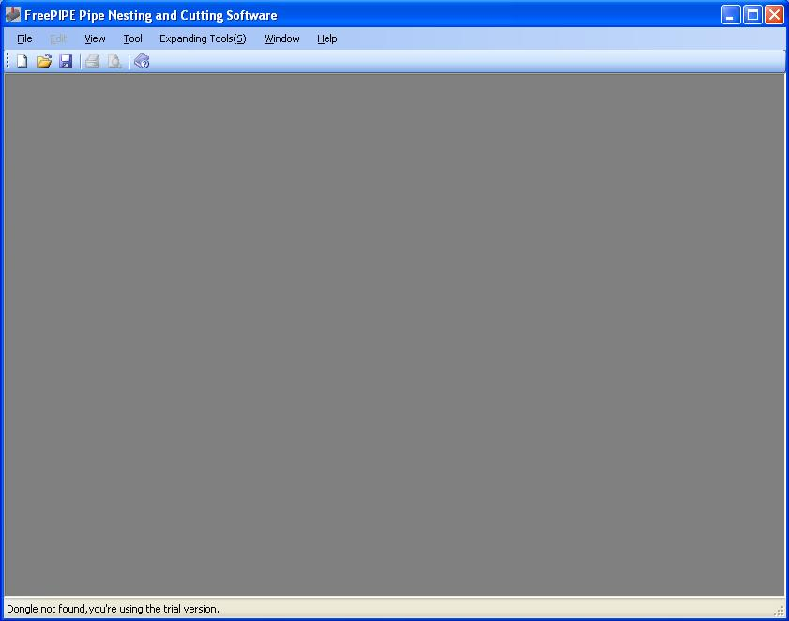
(Figure One)
When the main form is loaded, a warning dialog shown in Figure Two appears when the software is started if the software dog is not inserted properly.

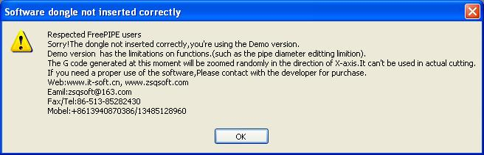
Figure Two
By this time you can only demonstrate the functions of the software or simulate by inputting the code generated by the software into cutting machine. Please do not use the code generated by the software for actual cutting, because the G code generated by the software at this moment will be zoomed randomly between 0.95 and 1.05 times in the direction of X-axis. If it is used for actual cutting, the workpiece may be scrapped. The cutting loss caused by the users' incorrectness of inserting the software dog is at the users' risk.

Under the main form, the "editing form of pipe", "automatic nesting form" and "G code generating form" can be built and opened. All the operations in this software are conducted under the main form.

First, we will introduce the the content of program setting. The content of program setting is in the menu of "Tool" under the main form.

Under the main form, we can also enter the setting form, which can be called in from the menu of "Tool" under the main form. The content of the menu of "Tool" is as following:

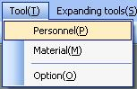
Figure Three

The Form of personnel Editing
Click the menu of "personnel", and enter into the form of staff editing, as shown in Figure Four:

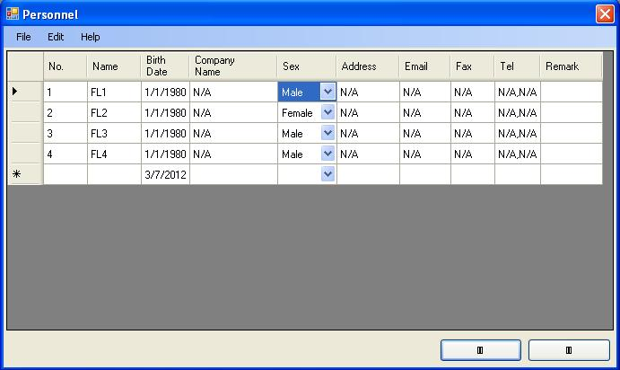
Figure Four
Under the form of personnel editing, the data content of personnel can be added, modified and deleted. It must be noted that the users have to click the button of "Save" under the menu of "File" after modifying the content to save the changes. Otherwise, the changes you have done will not be saved.

The Form of Materials Editing
Click the menu of "Materials", and enter the form of materials editing, as shown in Figure Five:

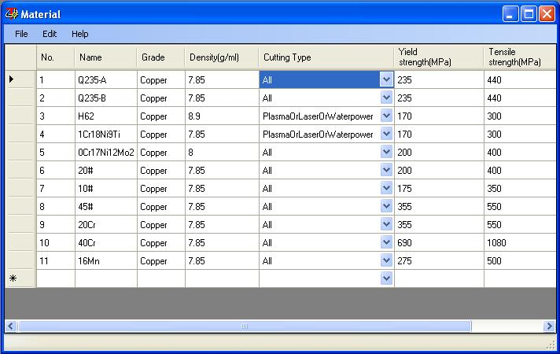
Figure Five
Please keep in mind that you have to click "Save" to save the changes you have done after editing under the form of personnel and material. Otherwise the changes you've done will be invalid.

The Form of Software Setting
Click the menu of "Option", and enter the form of main parameter setting of the software, as shown in Figure Six:

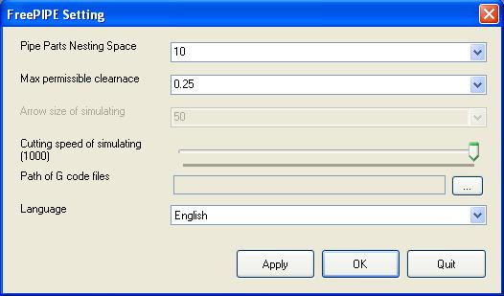
Figure Six
You can set some basic parameters under the setting form. The "Pipe parts nesting space" refers to the minimum permissible clearance from the steel pipe parts to the end of raw material and between the ends of pipe parts after nesting automatically the steel pipe parts onto the raw material of steel pipe.

The "maximum permissible clearance among the objects of graphic elements" refers to that it is considered as connected if the clearance among the graphic elements of CAD is less than this value when calling the graphs of CAD to generate tapping objects; otherwise it is considered as disconnected.

The options of "arrow size of simulating cutting" and "cutting speed of simulating" should be set according to the users' requirements.

Besides, the users can set the option of "Language" of this software according to their requirements. You can enter the language interface you need after setting and restarting the software.

Click "Application" to confirm the changes. Click "OK" to confirm the changes and exit the setting form. Click "Quit" to exit the form without saving the changes you've done.

The Form of Pipe Parts Editing
Click “New” or the toolbar under the main form, the form as shown in Figure Seven appears:

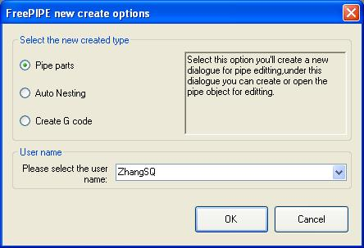
Figure Seven
Select the option of “Pipe part” under this form and click “OK”, a new pipe part editing form will be built by the program as Figure Eight shows:

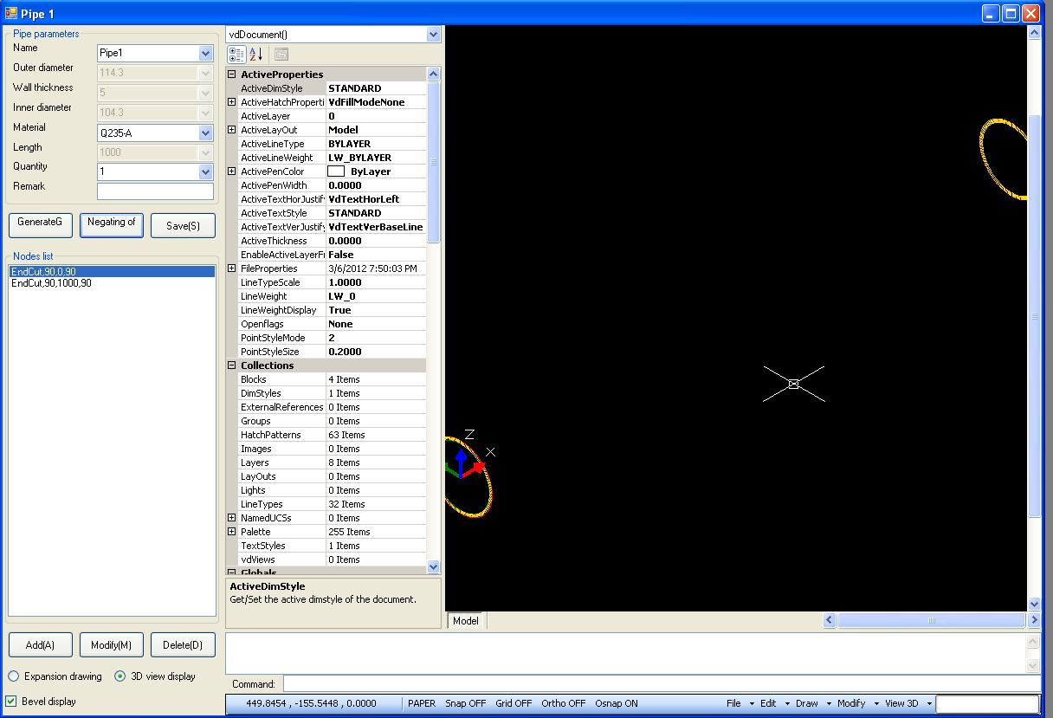
Figure Eight
The outer diameter, wall thickness, material, quantity and other parameters can be edited under this form.(Note: it has to be noted that this software will not be able to edit the outer diameter and wall thickness of pipe part which will be locked up at “114.3” and “5” if the software dog is not inserted properly. Please pay special attention to this.)
When the form is being built, the software will automatically build two vertical cutting, which are respectively located at the position of 0mm and 1000mm away from the theoretical origin, and can be deleted by the users if they are not needed. What should be noted is that one piece of pipe part has to have an even number of broad cutting (including cutting, the ends of branch pipes, three-pipe intersection, the ends of two branch pipes), otherwise an error will occur during the automatic nesting of the program, and no correct cutting code will be generated.

The Form of Node Selecting
All kinds of pipe nodes can be built or edited under this form. If more pipe nodes are needed, click “Add”, and the form of node selecting as shown in Figure Nine appears.

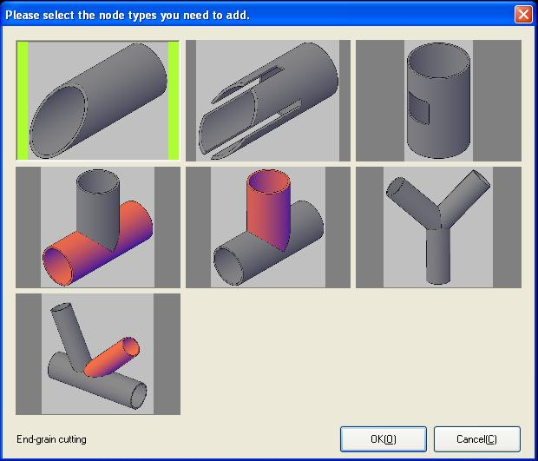
Figure Nine
Under this form, the node patterns which need to be added are vividly depicted in three dimensions. Different prompts will be obtained in the lower left corner of the form after you choose different patterns, whose background color will turn yellowish-green if selected. Click “OK” after selecting, and then enter the edit dialog of this node.

Now we will explain in detail the concepts and edit dialogs of these nodes one by one. They are the basis of the software. Please operate after figuring out the basic concepts and ideas of this software. Otherwise, errors are easy to occur.

End-grain Cutting
The dialog of end-grain cutting is shown in Figure Ten:

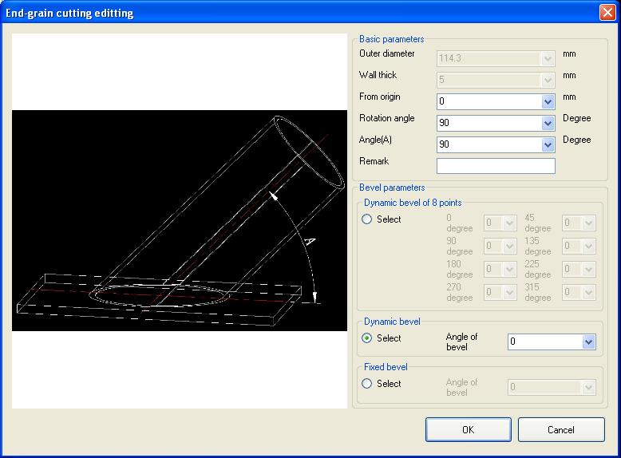
Figure Ten

The concept of end-grain cutting is easy to understand, which is to cut at the ends of pipes. End-grain cutting can be divided into vertical cutting and aslant cutting. All parameters of end-grain cutting can be customized under this form to achieve the results that you require.

The "outer diameter" and "wall thickness" of pipe under this form are not editable, because the parameters have to be consistent with those of the steel pipe and cannot be edited randomly. Otherwise, it may lead to an error. They are shown here in the aim of reminding, so they are grayed out in the program.

The parameter of “From origin” is very important, which determines the location of this end-grain cutting on the steel pipe. The distance refers to the distance from the intersecting point of this end-grain cutting surface and the center line of the pipe to the theoretical origin of the pipe.

Here the “Rotation angle” represents the angle difference between the angle of 0 position and the line formed when the center line of the pipe projects to the surface of end-grain cutting. The value has no effect when the angle of A is 90 degree.

The definition of “Angle of bevel” is the angle between the center line of the pipe and the line projected on the surface of end-grain cutting. If the angle is 90 degree, it means that the surface of end-grain cutting is vertical to the center line of the pipe. This angle has to be no more than 179 degrees, and no less than 1 degree. Otherwise, the program will automatically change it into the correct one which is the closest value to it.

You can define the bevel of this node under this form. The software provides three kinds of bevels that can be defined, as shown in Figure Ten.

Firstly, the "Dynamic bevels of 8 points" is the bevel size of the 8 points that respectively defined by the users according to their own requirements. The bevels of other points can be respectively calculated according to the angle linearity of the bevels of the 8 points. Note: this kind of bevel is not applicable for tapping on pipes, as well as intersecting line holes when generating branch pipes.

The second is "Dynamic bevel". Dynamic bevel, as the name implies, is the actual shape calculated by the software, together with the bevel angle you have set. However, the final bevel angle sometimes may exceed the extreme deflection degree of the cutting machine because of the superposition of the bevel angle. The software now will automatically cut according to the maximum defined bevel angle when generating code. It may has some error compared to your setting, but it basically does not affect your use.

The last one to introduce is "Fixed bevel". Fixed bevel refers to the calculation method of bevel in the angle which is vertical to the center line of the pipe and 0 degree, adding with the angle of bevel. When the software calculates in this way, it will guarantee the assembly and welding performance of the finished part being cut finally, based on the principle that it is better to cut more than less..

Slotting at the End
The dialog of slotting at the end is shown in Figure Twelve:

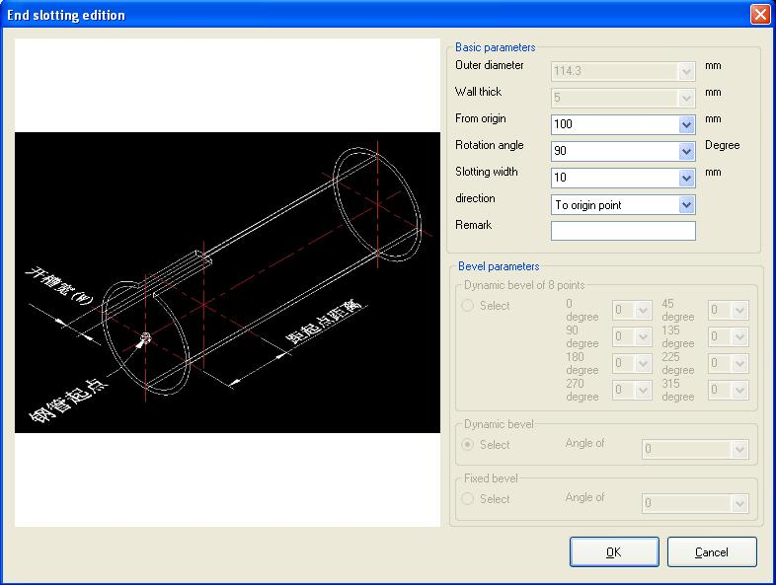
Figure Twelve
The “outer diameter” and “wall thickness” here are the same with end-grain cutting, which will not be described.

The “From origin” refers to the distance from the theoretical origin to the bottom of the slot. This point is not directly related to the surface of end-grain cutting that the slot reaches.

The definition of “Rotation angle” is exactly the same with that of end-grain cutting.

What has to be pointed out about the “Slotting width” is that it refers to the chord length of the circular inner surface of the pipe (projection distance), rather than the arc length.

The “Direction” of slotting means that the direction of slotting is toward or against the theoretical origin.

No bevel is allowed to add to the slots. Therefore, the content of “bevel” here is grayed out, which is not editable.

It has to be noted that the slotting node can not generate G code independently. It can generate G code only when combining with the node of broad end-grain cutting (including end-grain cutting, intersecting line end-grain cutting of branch pipes, end-grain cutting of three-pipe intersection and end-grain cutting of multi-pipe intersection).

Tapping
The dialog of tapping is shown as Figure Thirteen shows:

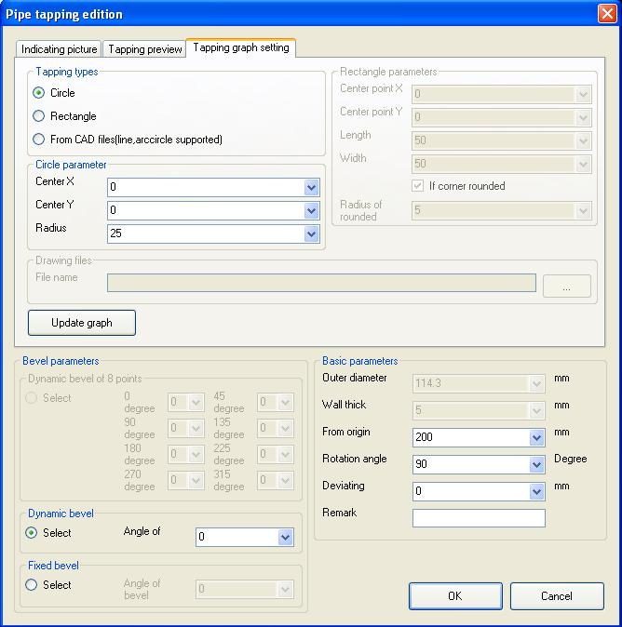
Figure Thirteen
The dialog of tapping is more complicated, because there are more parameters to be defined. Three kinds of tapping can be set in the option board of tapping graph setting. The first is circular hole; the second is rectangular hole; and the third is closed graph hole from the files DWG or DXF.

As to the “Circle, you can only define the position of the center and the length of radius.

As to the “Rectangle ”, you can also define the position of the center, the length and the width only. If there is a rounded corner, you have to define the radius of it (the radius of rounded corner has to be less than half the value which is the smaller one in the direction of length and width.).

“From CAD files” is more complicated. You can first draw the shape of the hole you need in CAD, save it in the format of DWG or DXF, and then call it in through this software.

Click “Update graph” after finishing setting the hole and enter the option board of “Tapping preview”, as shown in Figure Fourteen:

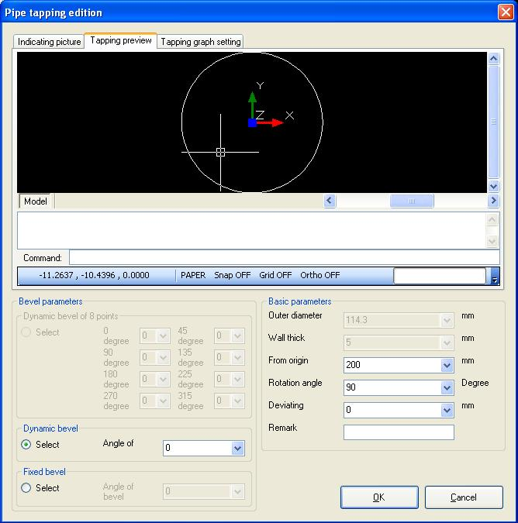
Figure Fourteen
As shown in the figure above, it is a tapping graph imported from CAD graphs, which can be any one of them. But it is better to be a “simple polygon” of geometric definition,, that is, there is no side of inner self intersection.

These parameters need to be defined after defining the graph, and the outer diameter and wall thickness are the same with that introduced previously.

The definition of distance "From origin" is much more different from the definition of others. The distance from the theoretical origin here is the distance from the origin of coordinates (0,0,0) on the tapping graph to the theoretical origin, but may not being the center point of the circular or rectangle (if the center point is not the defined coordinates of 0,0 point).

The definition of "Rotation angle" is the same with other nodes, which is the angle difference between the line that is vertical to the surface of the graph and passing through the origin of the tapping graph and the angle at 0 position of the pipe.

"Deviating" refers to that the origin of the tapping graph is not at the center of the pipe. Looking over the theoretical origin of the pipe to the direction of the pipe, the value deviating to the right side of the center line of the pipe is positive, and negative if deviating to the left side.

The tapping can only choose dynamic and fixed bevel. 8-point dynamic bevel is not applicable for this kind of node, so that it is unavailable.

Tapping of Intersecting Line When the Main Pipe Generates Branch Pipes
The dialog of intersecting line that the main pipe generates branch pipes is shown in Figure Fifteen:

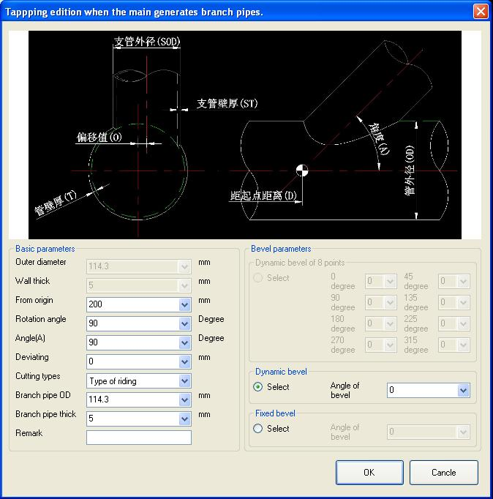
Figure Fifteen
The "Outer diameter" and "Wall thickness" under this form are the same with the definition of other nodes.

The definition of "From origin" refers to the distance from the intersecting point between the center of branch pipes and the projection line of the main pipe's center line to the theoretical origin of the pipe.

The definition of "Rotation angle" is the same with that of tapping, which is the angle difference between the center of branch pipes and angle 0 position of the main pipe.

The "Angle (A)" refers to the angle of the main pipe center and the center line of branch pipes, which is no less than 1 degree and no more than 179 degree.

The definition of "Deviating" is exactly the same with that of tapping.

There are three types of cutting, which respectively are "the type of connection of internal and external outlines", "Type of riding" and "the type that the branch pipes penetrates the main pipe".

Different intersecting line can be obtained by choosing any one of the three types. It has to be pointed out that "the type that the branch pipes penetrates the main pipe" requires that the outer diameter of branch pipes is no more than the inner diameter of the main pipe; otherwise there will be an error and the intersecting line can not be generated.

The outer diameter of branch pipes in all types of cutting is required to be no more than that of the main pipe, and the inner diameter of branch pipes is required to be no more than the inner diameter of the main pipe; otherwise the intersecting line cannot be properly generated.

There is no special requirement to the parameter of wall thickness of branch pipes. It is enough to meet the requirements of inner and outer diameters of pipes mentioned above.

"Bevel definition" is exactly the same with the bevel definition of tapping node.

End-grain Cutting of Intersecting Line Where the Branch Pipes and Main Pipe Connect
The dialog of end-grain cutting of branch pipes is shown in Figure Sixteen:

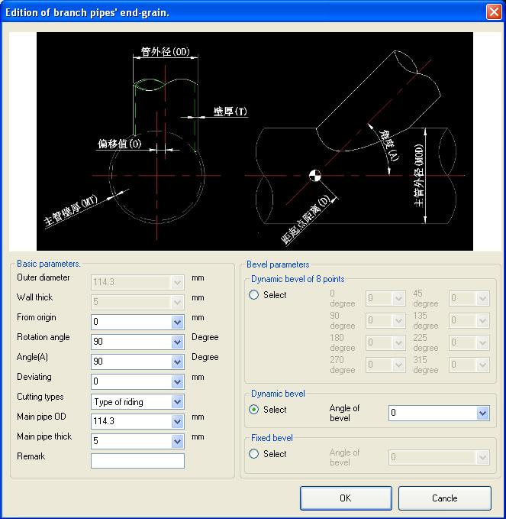
Figure Sixteen
The setting of parameters in this form is similar to that of tapping of intersecting line on the main pipe, except that the intersecting line of branch pipes is finally generated.
The difference is this type of nodes can use the 8 points dynamic bevel for this is one type of broad end cutting and not tapping.

Intersection of Three Pipes
The dialog of intersection of three pipes is shown in Figure Seventeen:

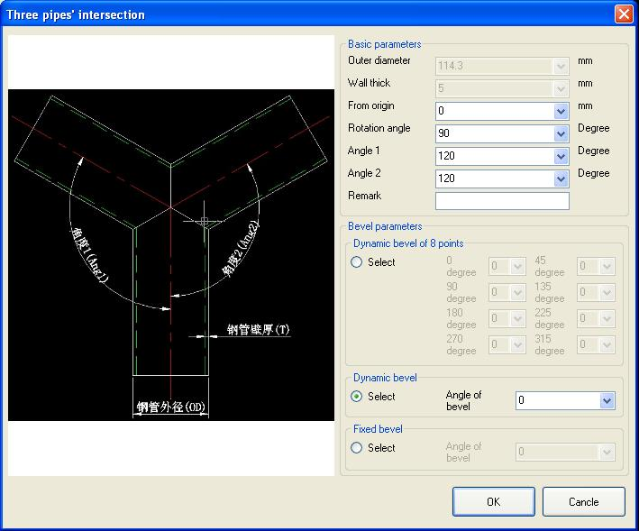
Figure Seventeen
The definitions of "Outer diameter" and "Wall thickness" are the same with that of other nodes.

The "From origin" is the distance from the intersection point of the three pipes' center lines to the theoretical origin.

"Rotation angle" is the angle of "angle 1" pipe center relative to the angle at 0 position of this pipe.

"Angle 1" is the angle between the center line of "intersecting branch pipe 1" and the center line of this pipe. "Angle 2" is the angle between the center line of "intersecting branch pipe 2" and the center line of this pipe.

The bevel definition is exactly the same with end-grain cutting.

Combined Intersection of Branch Pipe, Main Pipe and Another Branch Pipe
The edit dialog of the combined intersection of branch pipe, main pipe and another branch pipe is shown in Figure Eighteen:

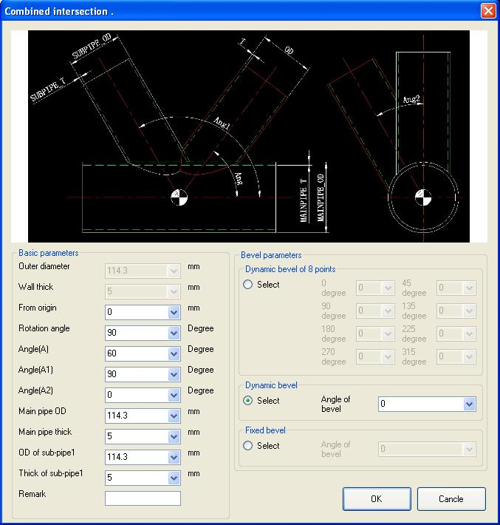
Figure Eighteen
Since three-dimensional transform is involved here, it may be a little difficult to understand the concept. It will be explained in detail in the following.

The "Outer diameter" and "Wall thickness" are the same with others, and they will not be repeated here.

"From origin" is the distance from the intersection point of the branch pipe and the center line of the main pipe to the theoretical origin, which is exactly the same with the definition of the ends of branch pipe.

"Rotation angle" is the rotation angle of the center line of the main pipe relative to the angle 0 position on this pipe.

The definition of "Angle" is the angle between the center lines of the branch pipe and main pipe on the plane defined by the branch pipes and the center of the main pipe. This angle has to be no less than 1 degree, and no more than 179 degrees.

The definition of the "Angle(A1)" between "branch pipe 1" and the main pipe is the angle between the center line of "branch pipe 1" and the center of main pipe on the plane defined by the center lines of "branch pipe 1" and main pipe. This angle has to be no less than 1 degree, and no more than 179 degrees.

"Angle(A2)" is the relative angle between the center of this pipe and the projection of the center of another pipe, looking forward from the rear-end of the main pipe.

The "Main pipe OD(outer diameter)", "Main pipe thick(wall thickness)", "OD(outer diameter)of sub-pipe 1" and "Thick of sub-pipe1" will not be repeated here. However, the outer diameter of the main pipe has to be no less than the outer diameter of branch pipe 1 and this branch pipe. The outer diameter of branch pipe 1 has to be no less than the outer diameter of this branch pipe. Otherwise, some errors in calculation will occur.

The "Bevel parameters" is exactly the same with the definition of end-grain cutting part.

We can modify or delete these nodes at any time after defining these nodes.

Modifying Nodes
Choose the corresponding node in the list of nodes, and click the button of modify, an edit dialog of this corresponding node appears.

Deleting Nodes
Choose the corresponding node in the list of nodes, and click the button of delete, a dialog as shown in Figure Nineteen appears.

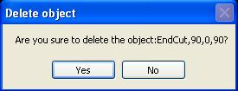
Figure Nineteen
Click "Yes" to confirm deleting; click "No" to cancel deleting.

Highlighting of Node Graph
After the user choose the node in the list of nodes, the corresponding graph of this node in drawing area will be highlighted.

Generating G Code
Click the button of "Create Gcode", and a dialog as shown in Figure Twenty appears.

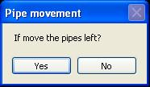
Figure Twenty
After click "Yes", the software will automatically put the steel pipe toward the left direction. Then a dialog which shows the distance that the pipe moves toward the left direction appears, as shown in Figure Twenty-one:

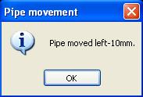
Figure Twenty-one
If a negative number shows, it means that the pipe moves toward the right direction.

After clicking "OK", a setting form of "Create G code" appears, as shown in Figure Twenty-two:

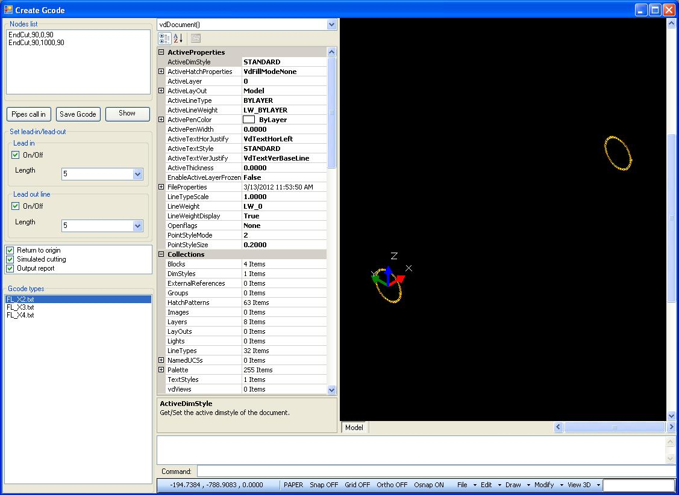
Figure Twenty-two
The details of the form generating G code will be explained in the following special section, and it will not be introduced specially here.

Pipe reverse
The so-called "Pipe reverse"is to generate the pipe part whose name is that of the current pipe with the character of "REV" behind by rotating the pipe by 180 degrees along the theoretical origin on the plane of XY.

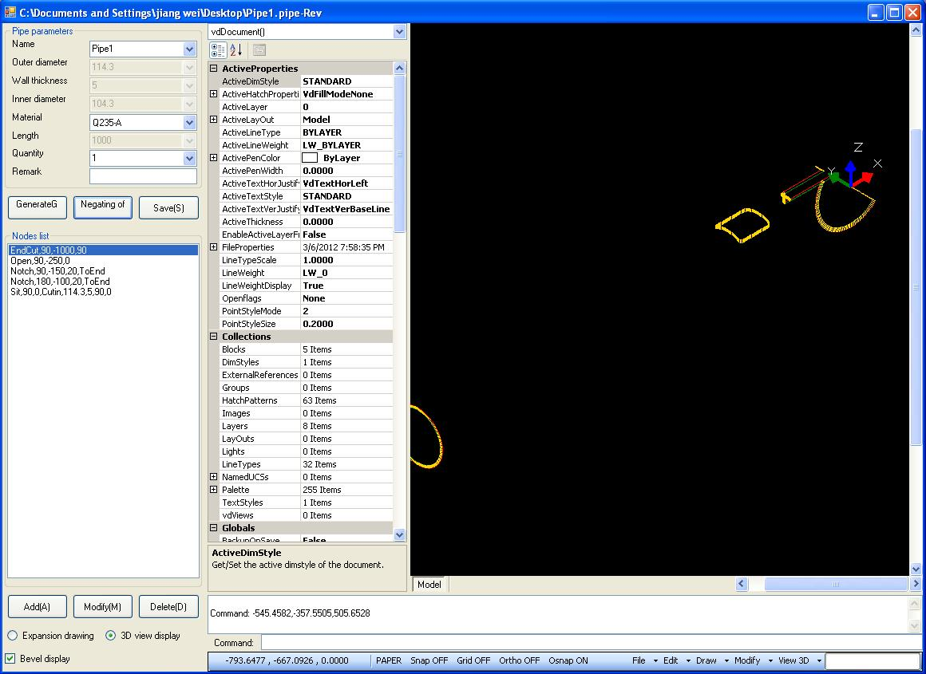
Figure Twenty-three

Save
Click "Save", and the information of the pipe part which is being edited under the current dialog will be saved into the hard disk . If it has been saved before, the dialog of saving will not appear, and the original file will be overwritten; otherwise, a dialog as following will appear, as shown in Figure Twenty-four:

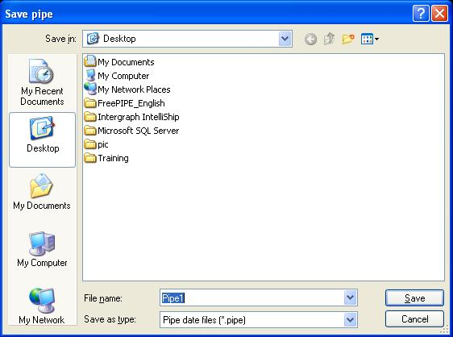
Figure Twenty-four
The program will default to save the file with the name of the steel pipe, whose extension is "*.pipe". Since the software is green software, it does not relate the files of the extension to this software, so that you have to open the software before opening the pipe files which have been saved in the software.

The Form of Automatic Nesting

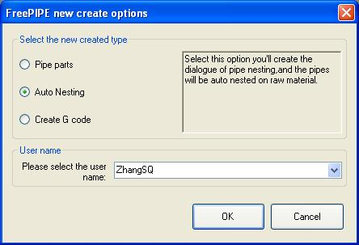
Figure Twenty-five
Choose "Auto nesting " under this form and click "OK". The program will build an edit form of automatic nesting of pipes, as shown in Figure Twenty-six:

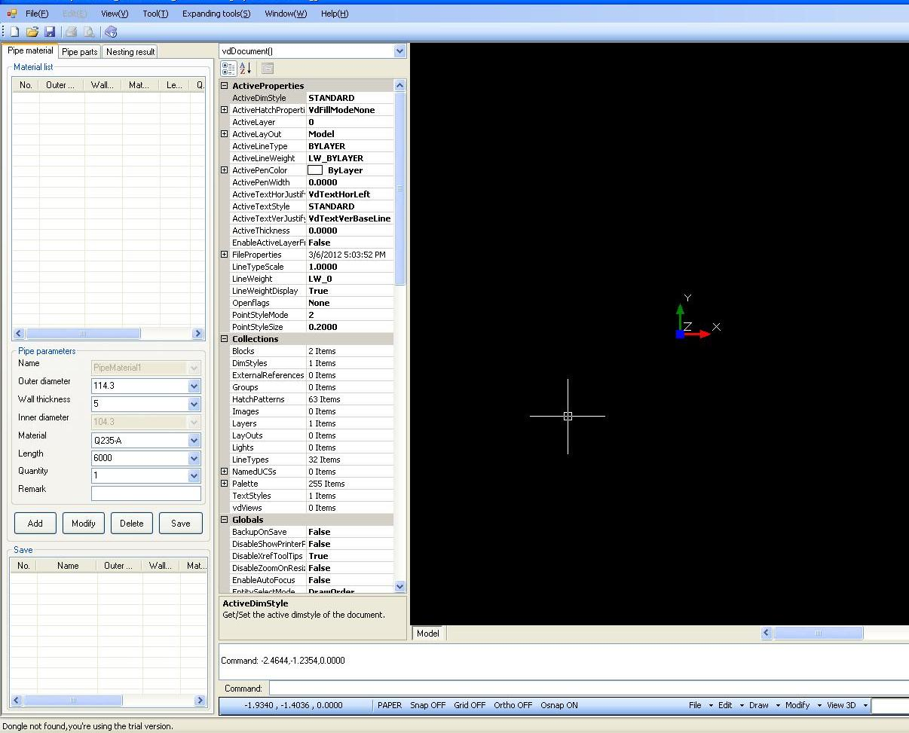
Figure Twenty-six
There are three option boards under the form of automatic nesting, which respectively are "Pipe material", "Pipe part" and "Nesting result". We will explain these items in the following.

Pipe Material
Under the option board of pipe material, we can input the specification and quantity of the pipe material. Then we input respectively four steel pipes of 114.3*5－6 meters and one pipe of 168.3*11－6 meters, as shown in Figure Twenty-seven:

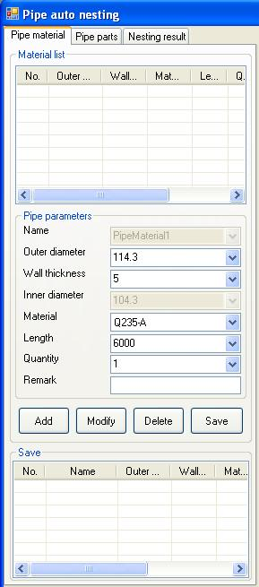
Figure Twenty-seven
Now we have finished the input of pipe material. We can also modify or delete the material information which has been input by clicking "Modify" or "Delete". Click the option in the list of material, the graph of this pipe material will appear in the drawing area.

Then we will perform the importing of pipe parts.

Pipe Parts
Enter the option board of "pipe part", and click the button of "Add". Add "PIPE1.pipe", "PIPE2.pipe", "PIPE3.pipe", "PIPE4.pipe", "PIPE5.pipe" and "PIPE6.pip” which have been saved before into the list of pipe parts, as shown in Figure Twenty-eight:

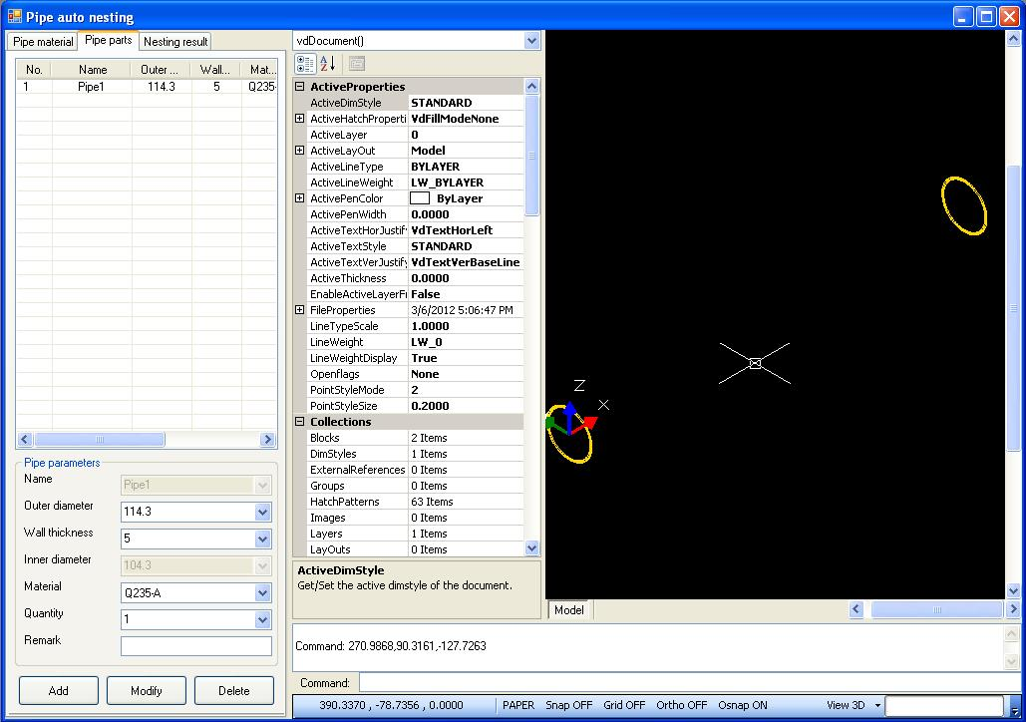
Figure Twenty-eight
The part which has been added to the list can be deleted by clicking "Delete".

Click the option in the list of pipe parts, the graph of this steel pipe will appear in the drawing area. The related information about this steel pipe will appear.

Nesting Result
We can conduct the automatic nesting after finishing all the preparations easily. We enter the option board of automatic nesting, as shown in Figure Twenty-nine:

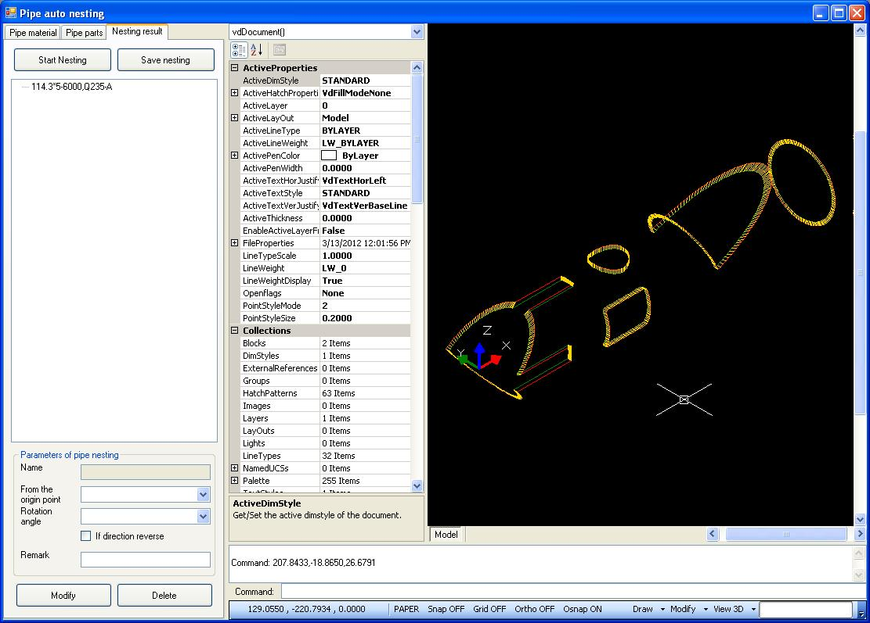
Figure Twenty-nine
Click "Start nesting", the program then will perform automatic nesting. Certain time is needed for the nesting and the nesting progress is shown in the lower left corner of the main form. The nesting result will be shown in the list of nesting result automatically after finishing nesting, as shown in Figure-Thirty:

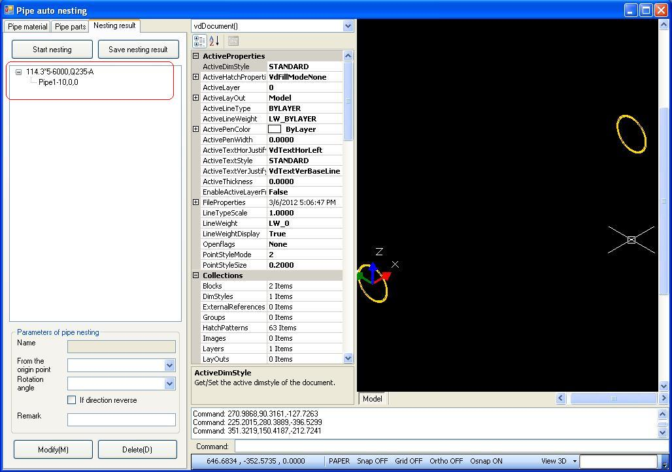
Figure Thirty
The part in the red box shown in the figure above is the list of nesting result, which is a tree structure with the trunk being the pipe material and the branches and leaves being the pipe parts nested into the material.

If we are not satisfied with the result of automatic nesting, we can also change the position and state parameters of the steel pipe after automatic nesting through the following edit area.

We can save the nesting result of single pipe. The details are shown in later sections.

Revealing of Pipe Part Matching the Pipe Material
The outer diameter, wall thickness and material quality of pipe part and material will be matched automatically by the software during automatic nesting.

Let's return to the option board of pipe material now. Different matching pipe part will show in the following list by clicking different materials of steel plate. These pipes can be nested automatically onto the pipe material we have chosen.
It is shown in Figure Thirty-one:

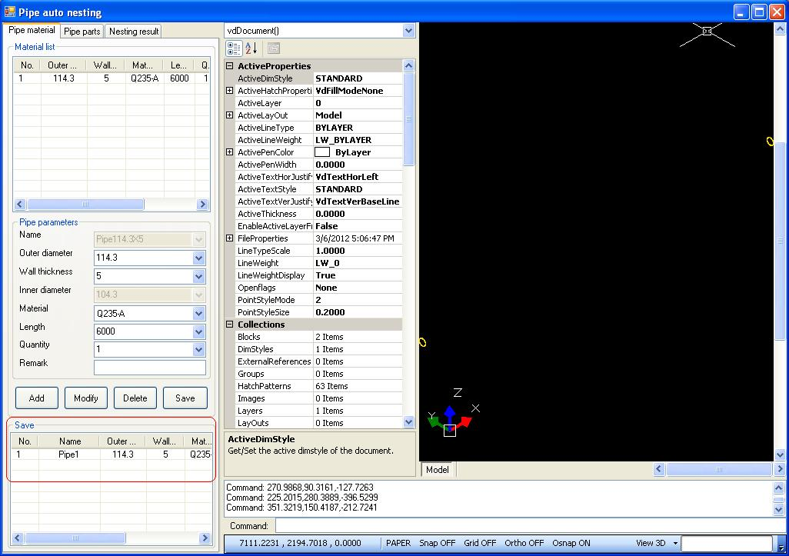
Figure Thirty-one
The details are shown in the content which is in the red box.

Saving the Information of Nesting
If we want to save the information of material and pipe part which have been input during this nesting, just click “Save” under the option board of pipe material. The extension of the file in which this nesting information is saved is “*.pnst”.

It has to be pointed out that the pipe part saved here has lost the relevance with the original file. Even if the original file is modified, the information of pipe here will not be modified automatically. The information of pipe can only be updated after deleting it in the list and re-importing.

Saving the Nesting Result of Single Pipe
If we want to save the result of nesting for the generation of G code, we can choose the material tree of steel pipe firstly, and click “Save nesting ” under the option board of “Nesting result”, then the nesting result of single pipe will be saved. The extension used by the file of single pipe nesting result is “*.spnt”

The information of single pipe nesting result can be directly used for generating G code, so that it can be called in by clicking “Pipes call in” under the form of “Create G code”.

Generating G Code

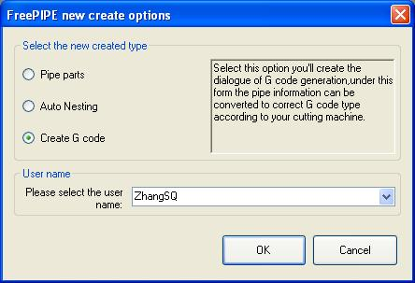
Figure Thirty-two
Choose the option of “Create Gcode” under this form and click “OK”, the program will build a form of generating G code as shown in Figure Thirty-three:

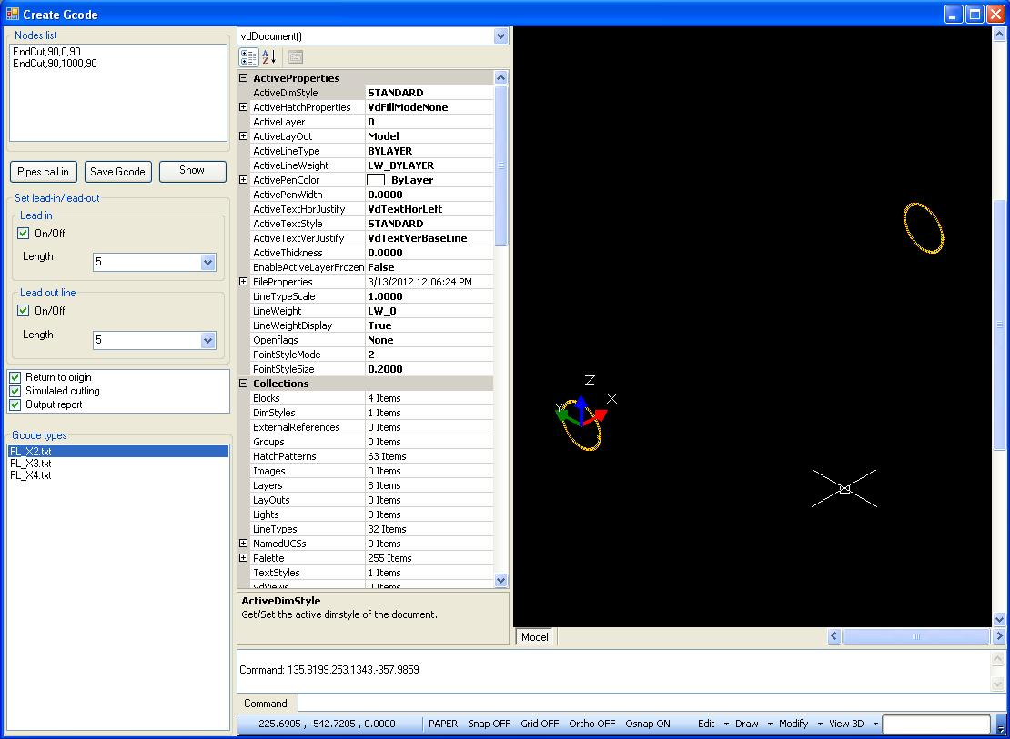
Figure Thirty-three
The functions under this form are clear at a glance. We can read in the information of pipes (the information of pipes and nesting result of single pipe can be called in; different information can be called in by choosing different extensions), save and reveal the G code.

The parameters of incoming and outgoing lines and some parameters used when generating G code for cutting can be set up.

Reading In the Pipe
Click “Pipes call in”, a dialog of reading in pipe appears, as shown in Figure Thirty-four:

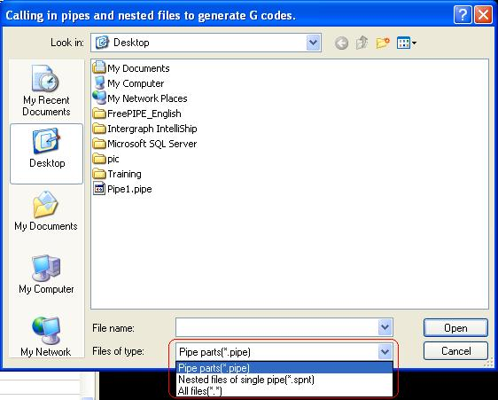
Figure Thirty-four
We can learn from the file types which we can choose that this software can not only read in the information of pipe parts, but also use the read-in of single pipe nesting result for the generation of G code. Let’s read in the information of one pipe part and one pipe material which has been nested respectively, as shown in Figure Thirty-five and Thirty-six:

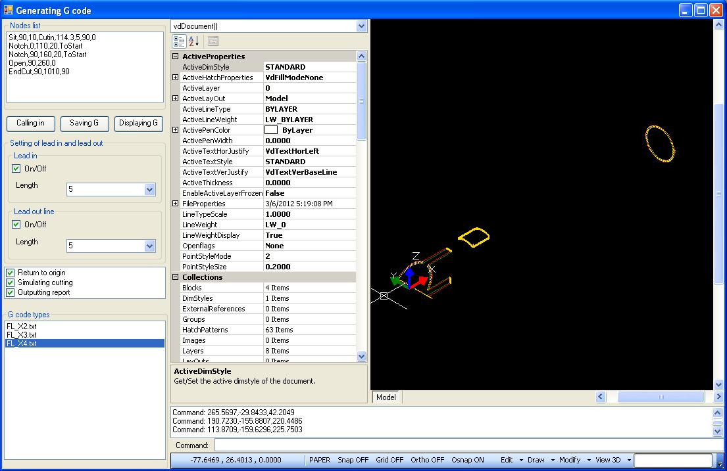
Figure Thirty-five
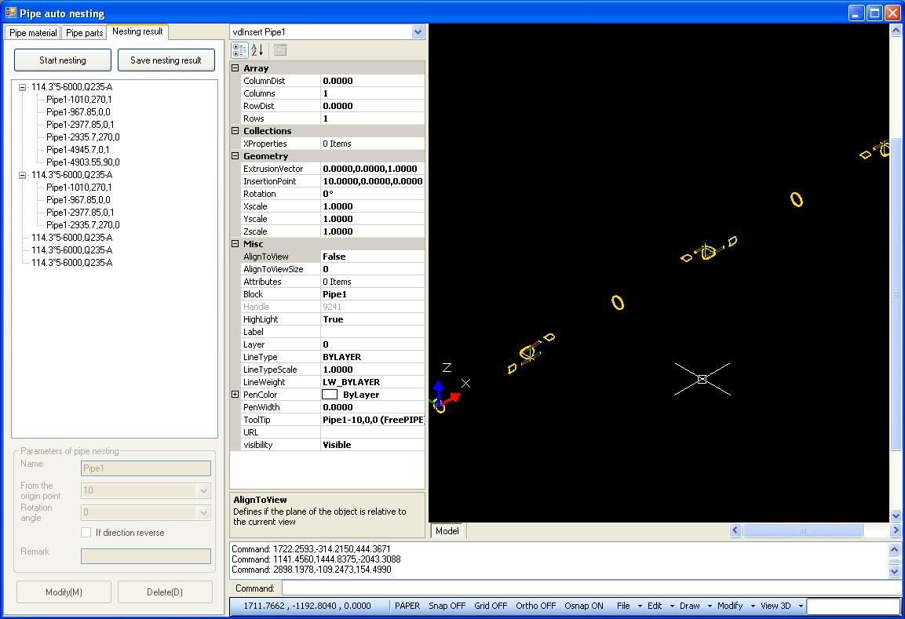
Figure Thirty-six
The node quantity in Figure Thirty-six is far more than that in Figure Thirty-five. It is the result obtained after complicated nesting of six steel pipes, so that its node quantity is much more. The computer may be a little slower when processing such a large quantity of nodes. Please be patient.

Modifying the Parameters of Lead-in and Lead-out Lines
We can also modify the incoming and outgoing lines by modifying the settings of lead-in and out lines on the interface. We can see the changes of graphs in the drawing area directly after modifying.

Savign G Code
Click “Save G code”, a dialog as shown in Figure Thirty-seven appears:

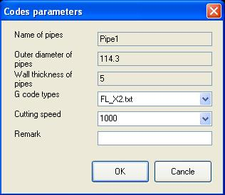
Figure Thirty-seven
Here we have to input the reference cutting speed of pipes. Click “OK” to move on; click “Cancel” to cancel the operation of generating G code. Let’s click “OK” to move on to the next step, as shown in Figure Thirty-eight:

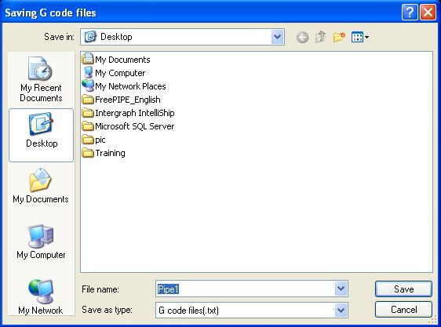
Figure Thirty-eight
After inputting the name of G code which needs to be generated, the program will automatically generate the G code for cutting according to the one you have chosen.

If you choose the option of “Output report”, the program will reveal automatically the report of this code which has been generated on the form after generating the code.

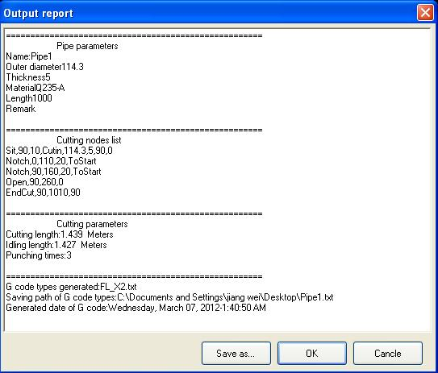
Figure Thirty-nine
By now, we have finished the whole process from generating part to generating G code. The G code can be copied to the cutting machine for cutting.

The G code can be opened by the program of “Notepad”, as shown in Figure Forty:

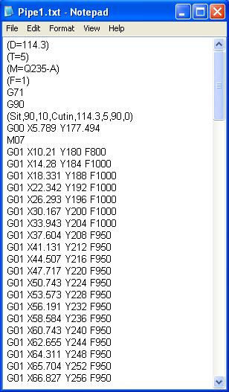
Figure Forty
After generating G code, the program will perform cutting simulation if the users have chosen the option of “Cutting simulation”.

Cutting Simulation
This software provides the function of three-dimensional cutting simulation. In the process of cutting simulation, the users can change different views to observe. If the users do not want to observe the process of cutting simulation, they can click “ESC” to exit at any time.

The process of cutting simulation is shown in Figure Forty-one:
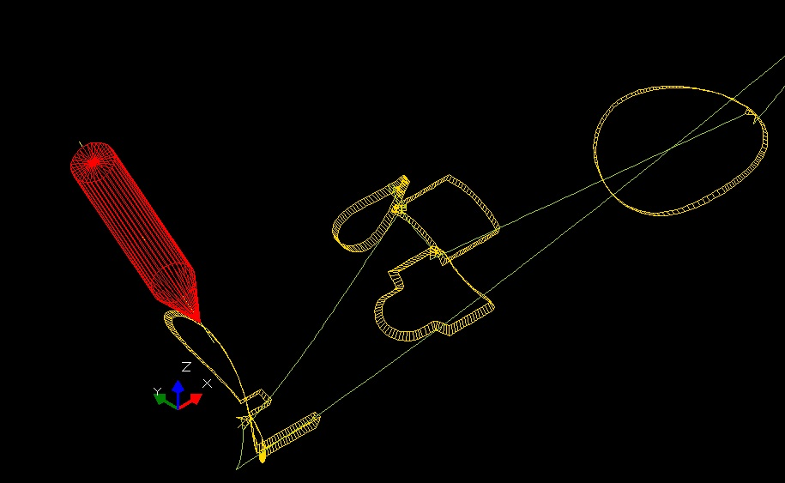
Figure Forty-one
The program has simulated the position and angle of cutting device, the shape of cut, the rotation angle of pipe, which are visualized.

The dialog as shown in Figure Forty-two will appear after the cutting simulation:

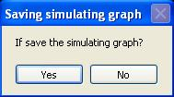
Figure Forty-two
Click “Yes” and the drawing area will keep the graph during cutting simulation; click “No” the graph during cutting simulation will be deleted.

G Code Call-in and Cutting Simulation
This software can call in the G code to generate graphs and simulate the cutting. Click “Show G code”, a dialog of choosing G code file as shown in Figure Forty-three will appear:

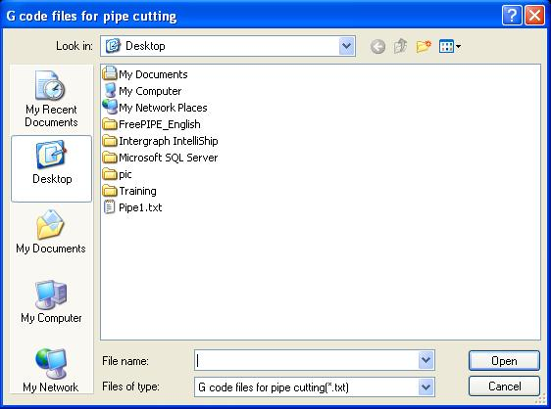
Figure Forty-three
After opening the G code, the G code graph will be generated and the cutting will be simulated. Please refer to the content of cutting simulation in last section.

Figure Forty-four is the graph after G code returns.
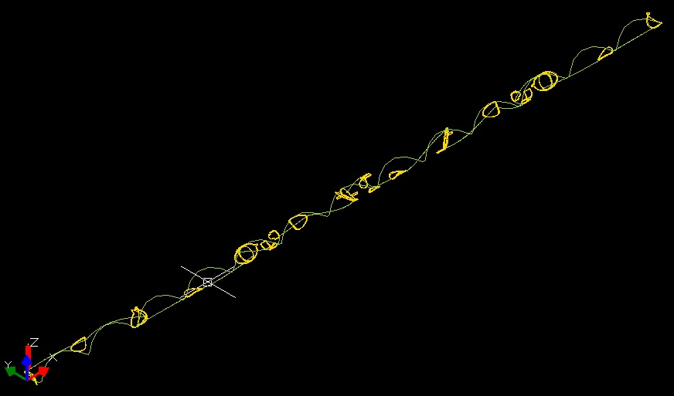
Figure Forty-four
By now, we have introduced the whole process from generating steel pipe to automatic nesting to generating G code. If there is any problem in the process of using, the users can contact with our customer service.

Extended Tools
There is a toolset for extending the functions of the software under this menu. Let’s introduce them one by one.

With the release of this software, the content of this menu will increase gradually to meet the special requirements of different customers. You can call or send email to us if you have some special requirements.

Generator of Split Elbow
The generator of split elbows can generate elbows conveniently, and generate it into pipe part used for cutting automatically.

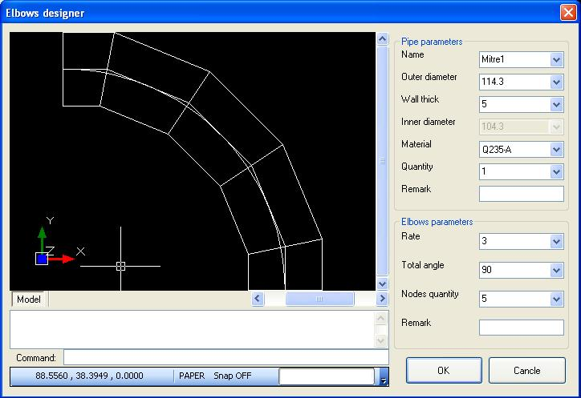
Figure Forty-six
Under this form, the elbow you need can be generated automatically according to the parameters you input. The content above is the information of steel pipe which needs to be input, and we will not further introduce it here, because it is the same with all the inputting interface of pipe information introduced previously.

The input of elbows parameters will be introduced in detail here.

The "Rate" of radius to caliber is the ratio of the elbow radius to the outer diameter of the pipe , which defaults to be three times. You can input by yourself, but the value that the software has set is no less than 1 ; otherwise the program will impose the value to change from less than 1 into 1.

The "Total angle" of elbow refers to the angle difference between the final angle and start angle of the elbow. The software sets the angle to be no less than 5 degrees and no more than 180 degrees; otherwise the software will impose the value you have input to be 5 (when it is less than 5) or 180 (when it is more than 180).

The "Nodes quantity "of elbow refers to the node quantity of straight pipe needed to fit the elbow. The software sets the value to be no less than 2 and no more than 30; otherwise the software will impose the value to be 2 (when it is less than 2) or 30 (when it is more than 30).

After you change the parameters above, the shape of the elbow will be generated automatically and reveal in the drawing area on the left, which facilitate you to check whether the parameters you have input is correct in real time. You can also save the generated graph into the files of DWG or DXF format for you to check and verify in CAD software.

Click "OK", the software will transform automatically these parameters you have input into a steel pipe, and put the cutting nodes in order automatically. The distance between nodes is the value of Pipe parts interval under the form of Setting".

Click "cancel", you will exit without any operation.

The Operation in the Drawing Area
The software has its own powerful function of drawing. The drawing area provides most of the CAD functions, where the users can finish most of the drawing. Besides, the drawing area has its own command line, by which the users can operate precise drawing.

You can observe the pipe you are editing in different views when the pipe is being edited.

The menu of the drawing area is located in the lower right corner of the form, as shown in Figure Forty-five:

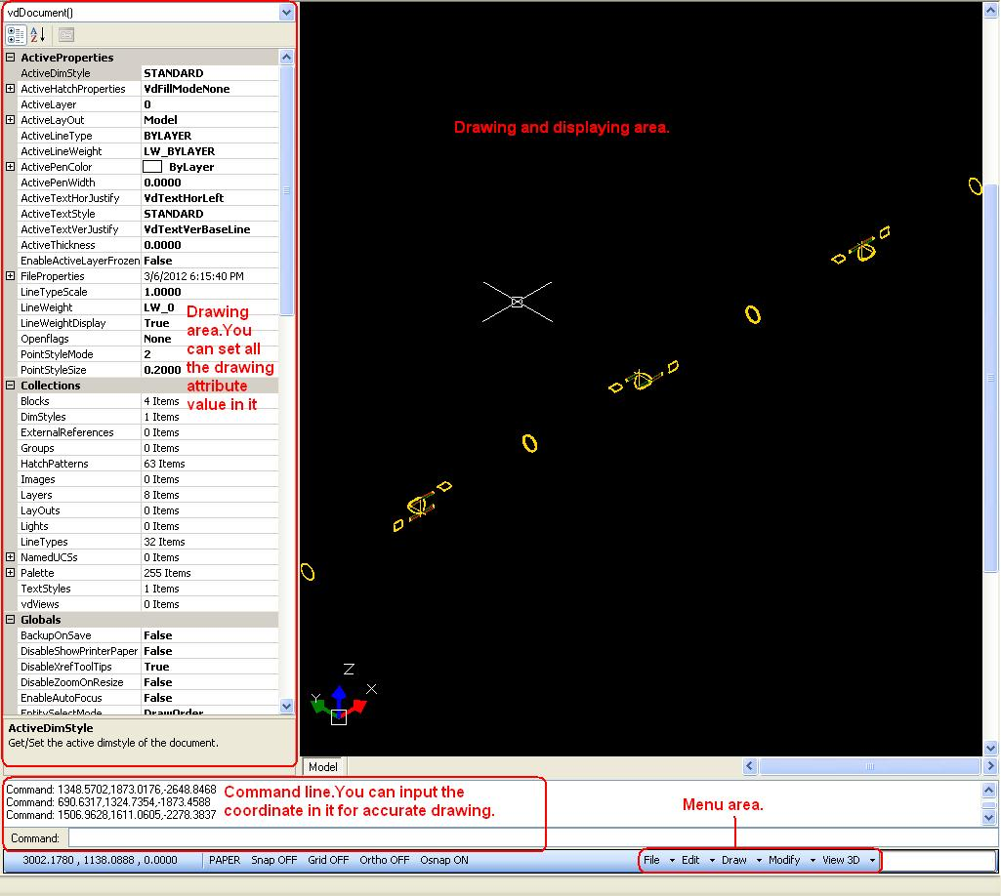
Figure Forty-five
The users can choose different views and conduct dynamic observation in real time through the menu of "View 3D".

In a word, the operation in the drawing area is very similar to that of AutoCAD. As long as you have the basis of AutoCAD usage, you will be able to use it skillfully in short time.

However, you have to note that the direction of rotation angle rotating around X axis in the drawing area is opposite to the definition of AutoCAD, and there is a 180-degree difference between the definition of 0 angle and AutoCAD. Please pay attention when you are using.

Introduction to the Distribution of Trail Encryption Lock with Time Limit
The manufacturers of cutting machines can ask us for the version with encryption lock through QQ, telephone or email. The trail version with encryption lock can perform the cutting and usage as the same as the formal version. But the trail version has the limits of time and frequency, so that you have to contact us and provide your detailed information to ask us for the encryption lock with time limit, by which we can provide better service.

Contact Us

About Us
Nantong IT-SOFT Company Ltd. was built in July, 2011, which is a high-tech professional company engaged in developing related software on CNC.
Our products now include FreeCAM——CNC Cutting&Nesting Programming Software, Free PIPE——Pipe Cutting&Nesting software, GEN to Gcode——the software that transforms the files of GEN generated by Tribon into NC code (with bevel), etc. We can also provide the service of program customizing.
Our company is going to take the professional technology and quality service as the fundamental. We will be your optimal partner.

Address and Contact
Nantong AiTe Software Company Ltd.
Room 310, No. 486, Gongnong Road, Nantong, Jiangsu

WEB : www.it-soft.cn
TEL : +86-13485128960
QQ : 12620857
FAX : +86-513-85282430
Email : zsqsoft@163.com

